808 Car keys Micro Camera
720 x 480 Video recording at 30FPS
1280 x 960 Photo Resolution

Below you will find instructions for using the cameras controls and general information about the function of the device. If you have any questions that are not answered here don't forget you can contact us by visiting eBay and sending us a message!

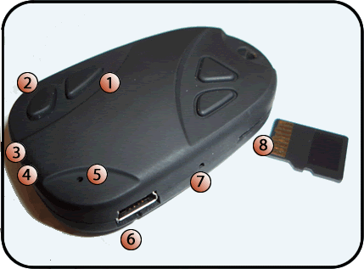
- Power On/Off
- Video/Photo Capture Button
- Microphone
- Camera Lens
- Indicator Light
- Mini USB charging Socket
- Reset switch (recessed)
- Micro SD card slot (SD Card NOT Included)

- Device Power On/Off
Press and hold button (1) to turn device on. Light illuminates to indicate device is ON. Press and hold again to turn device off. Light goes out to indicate device is OFF.

- Video/Photo Capture Button
Photos:
After turning the unit on, the light is illuminated to indicate device is ready for use. Press button (2) to take a photo. The light will momentarily go out to indicate the photograph has been taken and then come back on. Each Press will take another photograph.
Videos:
After turning the unit on, the light is illuminated to indicate the device is ready for use. Press and hold button (2) to begin video recording. The LIGHT FLASHES 3 TIMES AND THEN GOES OUT to indicate that the device is recording. The Device will continue recording until button (2) is pressed once to stop recording. The Light comes back on to indicate recording has stopped. If left recording, the device will continue until the memory card is full, the battery runs out, or button (2) is pressed.

- Microphone
The Microphone is used for recording audio during video capture. Do not obstruct or the sound quality will be significantly reduced.

- Camera Pinhole
Pinhole recess for camera lens. Be sure to keep clean and unobstructed for maximum clarity in your video captures.

- Indicator Light
Light indicates device status.
On Charge: Yellow light on solid (full charge approximately two hours).
In Use: Waiting = yellow light on solid.
Low Battery = yellow light flashes slowly

- Mini USB Charging Socket & Charging The Device
Mini USB charging socket for use with the included Mini USB charging cable connected to a desktop

or laptop computer for charging. You can also use car or mains USB charging adaptors. We recommend an overnight charge (at least 8 hours) for maximum capacity of up to 2hours. Actual time will vary slightly due to subtle differences in the batteries.

- Reset Button
In the event of a software crash where the buttons will not respond you can press and hold the reset button with a paperclip for approximately 3 seconds, to power off and perform a full factory reset on the device. This will also reset the internal clock.

- MicroSD Card Slot (SD Card NOT Included)
This slot houses the MicroSD card used to store the photos and videos you capture. It supports MicroSD cards from 2Gb to 16Gb in size. The table below gives you an indication of the quantity of photos or videos you can take on a single memory card. The values within are for Photos OR Videos, not both.

 | Photos | Video
2Gb | 13500 | 40mins
4Gb | 27000 | 80mins or 1hour 20mins
8Gb | 54000 | 160mins or 2hours 40mins
16Gb | 108000 | 320mins or 5hours 20mins
Approximate Memory Card capacity for Photos OR Videos

Viewing Videos/Photos
Retrieving your photos and videos is the same as most modern cameras. Simply remove the MicroSD card from the device and place into your card reader. Navigate to the card reader disc drive on your computer and enter the “DCIM” folder. All files stored on the SD card by the device are named “EKEN0001” and continue upwards numerically. Photos have the extension .jpg and videos the .avi extension.

Time Set
The device comes with a feature which embeds the current time and date on to your captured photos and videos. To set the time and date of the device, please follow the instructions below.
- Place the SD card into your computers card reader.
- Make sure you are on the “root” (top level) folder of the SD Card.
- Create a new file with the name TAG and extension .txt (TAG.txt) 4. Open the file and write the following information (exactly as shown):
[date]
2010/12/31
12:00:00
This example would set the unit to 12am on the 31st of December 2010. You can customise the information to represent the current time in your area. Save the changes to the file (TAG.txt) and place the SD card back into the Camera device. When you next turn on the device it will automatically read the TAG.txt file and, change its internal date and time settings to the information you have provided.

